1. Name 2 Razor keywords and 2 C# Razor keywords

Razor: OnGet, IActionResult

C#: OnPostAsync, await

1. What does the @page directive do?

Makes the file into a MVC action, This means that it can handle requests.

1. What is the @model directive do?

Specifies the type of model passed to the Razor Page.

1. What folder and file contains the markup that each page shares?

Pages/Shared/_Layout.cshtml in the shared folder.

1. What Razor command is a placeholder for other page-specific views to show up?

RenderBody

1. How does Razor transition into C# code?

HTML

@{C#}

HTML

1. What's the purpose of ViewData?

Passes data form the view into the database.

1. After changing the title element in _Layout.cshtml, run the app and screen print.

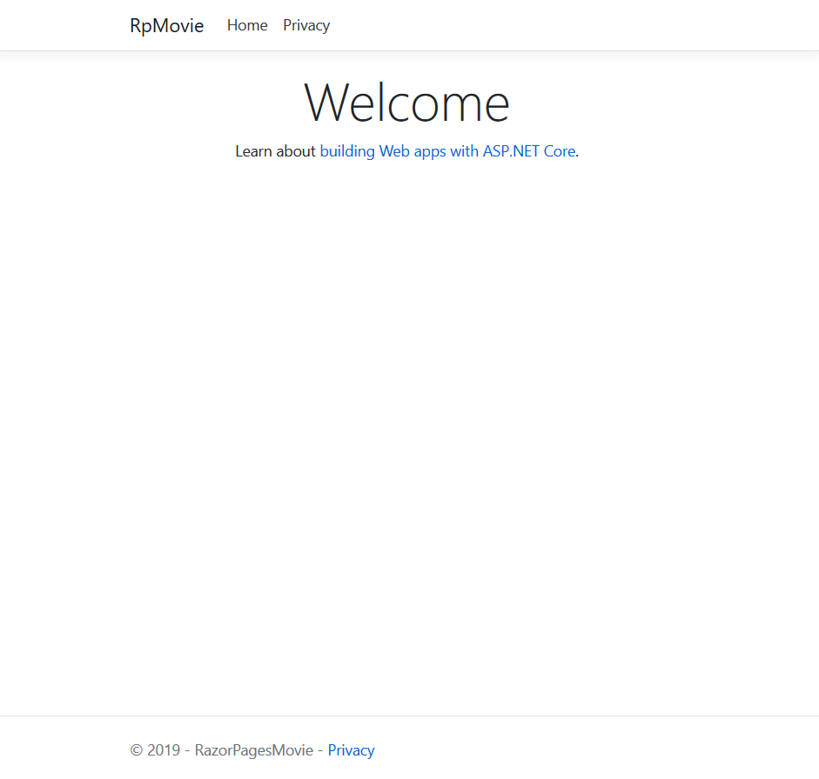

1. When a record is being created, the Create form posts the values to the server. What does ASP.NET then do? What method in the Create.cshtml.cs file is run to do this?

OnGet method initializes any state needed for the page.

1. What is an antiforgery token?

When a user is authenticated, they're issued a token. The token contains user information in the form of claims or a reference token that points the app to user state maintained in the app

1. List 3 Tag Helpers covered in this tutorial section.

Validation Tag Helpers, Label Tag Helper, Input Tag Helper